Use this protocol for the analysis of longitudinal global brain measures, subcortical structures, cortical thickness and surface area data within FreeSurfer ROI's for the ENIGMA plasticity working group
If you have any questions or run into problems, please feel free to contact Rachel Brouwer (r.m.brouwer-4@umcutrecht.nl)
These protocols are offered with an unlimited license and without warranty. However, if you find these protocols useful in your research, please provide a link to the ENIGMA website in your work: www.enigma.ini.usc.edu
Step 2: Quality Checking (Longitudinal FreeSurfer data)
Highlighted portions of the instructions may require you to make changes so that the commands work on your system and data.
There are four major steps for quality checking the segmentations outputted from FreeSurfer.
- Outlier Detection: This is a simple R script that will identify subjects with global volumes, subcortical volumes cortical thickness and surface area values that deviate from the rest of your subjects as well as subjects with deviating change measures.
- Subcortical Structures and Internal Surface Method: This method uses a Matlab function to plot subcortical structures and cortical surface segmentations directly on a subject’s scan.
- External Surface Method: This is loosely based on the QATools for FreeSurfer. This creates snapshots of external views of the segmentations from different angles.
- Creating a QC webpage: This step created a webpage in which all the images per subject are put together for baseline and follow up.
IMPORTANT NOTE: Steps 2-4 are very similar to the quality checks for ENIGMA-2 & ENIGMA-3, but combines snapshots of baseline and follow-up measurements per subject for easy comparison.
Make a directory to store all of the QC output.
mkdir /enigma/longitudinal/QC_figures_ENIGMA_LONG/

1. Outlier Detection:

This step requires that you have R installed (download here).
Change directories to the location of your ENIGMA_LONG.csv generated in Step 1 of the protocols. Make sure the outliers_long.R script is also in that directory and run:

R --no-save --slave < outliers_long.R

This will generate a file outliers_long.txt that will tell you which subjects are outliers and for which structures they are outliers for. The first part of the log file reports the number of outliers per subject, and the second part tells you which structures are involved. This file is used in the creation of the QC pages.

Note: As we are testing many variables, it is to be expected that most subjects are outliers on a few structures. Please pay close attention to those subjects that are outliers on many variables, and on those structures that are outliers on both the change measure and baseline/follow-up in the segmentation checks below. If a subject is segmented properly in FreeSurfer (which you will visually verify at later steps in this protocol) then please do keep them in the analysis.

IMPORTANT NOTE: If QC was already done on your (baseline and followup) data for ENIGMA-2 and ENIGMA-3, please only (double) check the subjects that are listed as outliers for the change measures in the steps below!

2. Subcortical structures & Internal Surface method

Prerequisites:

- Matlab
- Unzip the QC_ENIGMA_LONG.zip package.

Assuming that you have downloaded the collection of Matlab scripts and unzipped, change directories to that folder with the required Matlab *.m scripts. For simplicity, we assume you are working on a Linux machine with the base directory /enigma/longitudinal/
Start Matlab: /usr/local/matlab/bin/matlab
Add the current folder containing all of the required scripts to Matlab’s path.
Select: File -> Set Path -> Add Folder -> {OK} -> {Save} -> {Close}
The script we want to run is called create_long_pngs.m.
Edit lines 7-10 such that line 7 contains a path to the longitudinal_ENIGMA_subjects.txt. Lines 8-9 should refer to the parent directories for the freesurfer output for baseline and followup. Line 10 should refer to the QC output directory above. Save.
The create_long_pngs.m script should take approximately 2.5 min/subject and will output a series of *.png image files separated by individual subject folders.
Note: this script will produce warnings that directories already exist: this is not a problem.

3. The External Surface Method:
Prerequisites:
- FreeSurfer and its utilities need to be in your path or this fsqc_long.sh script will not run properly. You can type tksurfer on the command line to make sure it is available.

The script fsqc_long.sh will create with lateral and medial snapshots of pial surface reconstructions colored with cortical labels. To run the script, first open fsqc_long.sh and edit the paths to the Freesurfer main parent directories containing base and follow-up data, the path to the QC output directory created above and the path to the file longitudinal_ENIGMA_subjects.txt created in step 1 (lines 3-6). Now,
source fsqc_long.sh
This script will call `tksurfer` in a loop for each subject and output a series of 8 images (.tif) files for each subject. This script will take about a minute per subject. While running, windows will pop up and close automatically. This will likely limit the work you can do on your computer in the meantime and is probably best run overnight.

4. Making the QC Webpage:
To create a webpage for easy viewing of the QC output you just generated in Matlab and through the fsqc_long.sh script. Go to the directory where you stored the script make_ENIGMA_LONG_QC_webpage.sh and make sure it is executable:
chmod 755 make_ENIGMA_LONG_QC_webpage.sh
Now to run the script, just give the script the path to the directory where you stored the Matlab QC output files + (paths to) the subjects file and outlier file
./make_ENIGMA_LONG_QC_webpage.sh /enigma/subjects/QC/ /enigma/longitudinal/longitudinal_ENIGMA_subjects.txt /enigma/longitudinal/outliers_long.txt
NB: If you have trouble running this script, it’s possible that you need to fix the line endings in the script before running. You can do this by running this command: sed -i -e 's/\r$//' make_ENIGMA_QC_webpage.sh
This script will create a webpage called ENIGMA_LONG_QC.html in the same folder as your QC output. To open the webpage in a browser in a Linux environment you can probably just type:
firefox /enigma/subjects/QC/ENIGMA_LONG_QC.html
Note: if you want to check the segmentation on another computer, you can just copy over the whole /enigma/subjects/QC/ output folder to your computer and open the webpage from there.
The main QC page contains a list of subjects. On a separate page, each subjects’ baseline and follow up scan are displayed together and structures that are outliers are listed. Scroll through the subjects’ pages. Note that you can click on a subject’s files to see a larger version. An example page can be found in the ENIGMA_QC_LONG folder.
The first ENIGMA plasticity GWAS includes only global and subcortical volumes. The cortical structures are included for future use in this or other working groups, and as a general check to see whether the brain is well-segmented, i.e. to check whether global volumes can be expected to be reliable.

NOTE: you can use the legend.jpg file and FScolors.png found in the ENIGMA_QC_LONG folder as a colored coded reference of each FreeSurfer ROI (split by left/right).

If subcortical segmentations, cortical labels or surface reconstructions are bad:
- Open the data file ENIGMA_LONG.csv in Excel
- If the whole subject is poorly segmented you can delete the subject's row from the data files or mark all of the entries in a subject's row with "NA". This serves as a quality check for the global volumes.
If cortical measures are required for the analysis:
- Mark poorly segmented cortical regions with "NA" (without the quotes) for thickness AND surface for baseline or follow up (whichever is appropriate) AND change in thickness AND change in surface area. Also mark bordering regions as they may be badly segmented too.

- Make sure to save the files back in CSV format!

Here are examples of good segmentations:

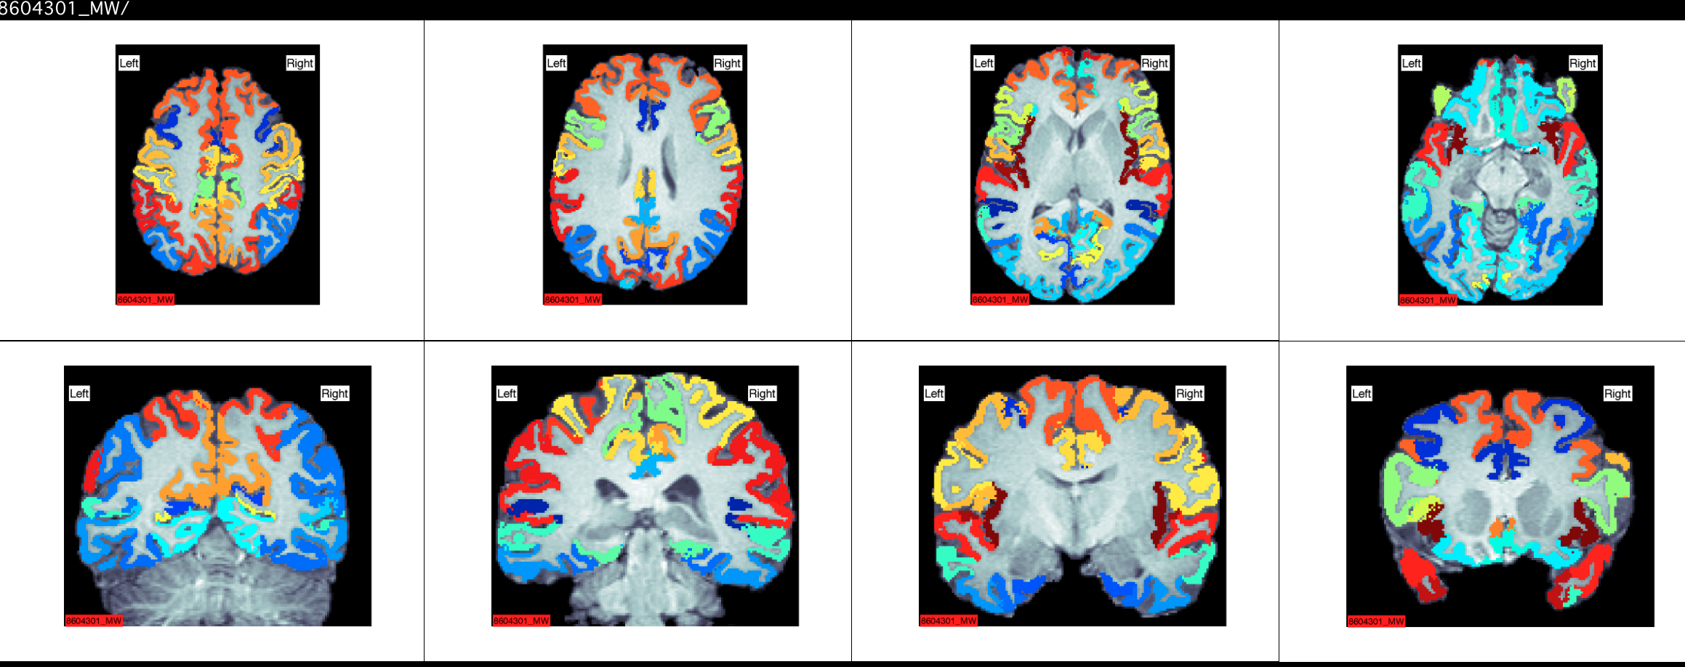

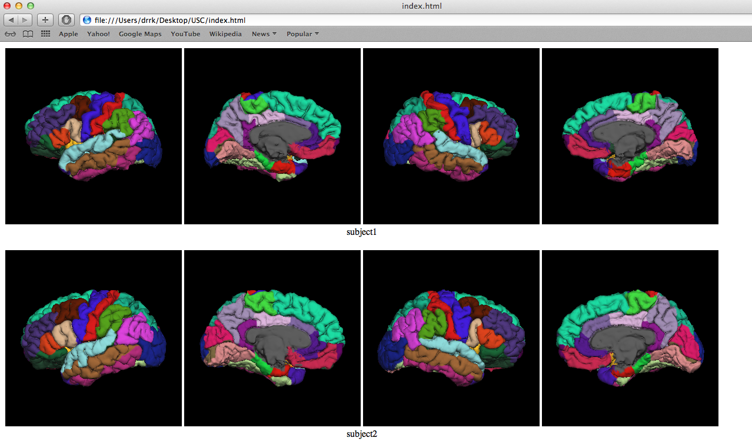

Here are examples of BAD segmentations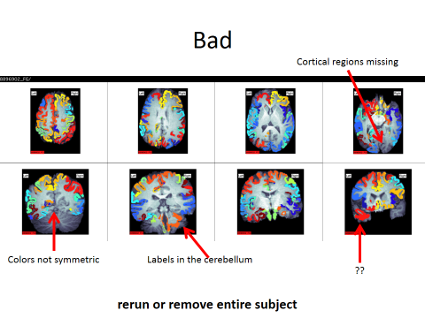
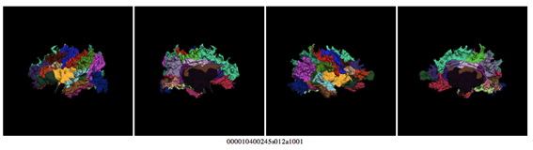

And a close-up shot of a good vs. bad segmentation:

Good:

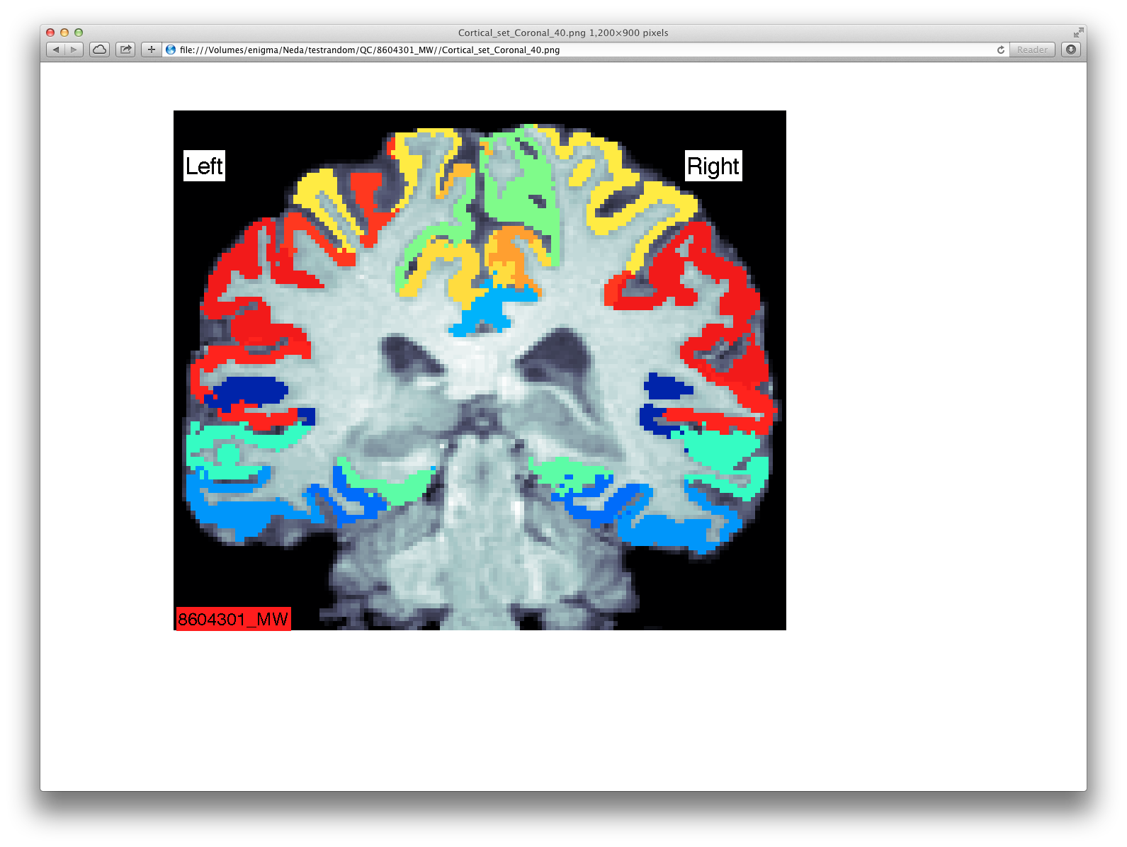
Bad:

